**ASSIGNMENT 1**

**Name – ANIKET NARALE**

**Install GIT & make sure it is added into PATH.**

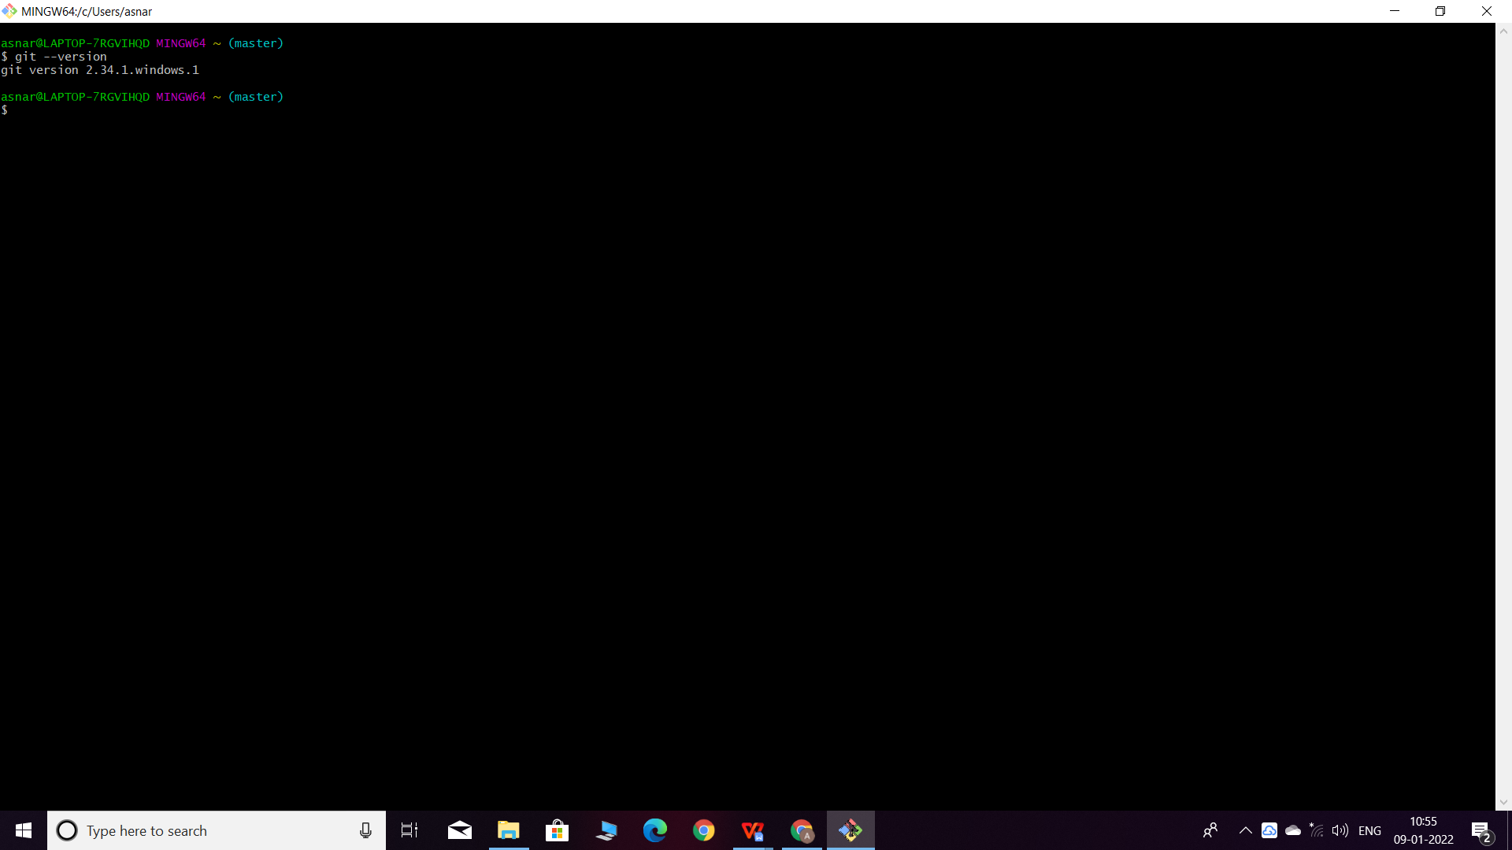

1. Create a directory ‘project_dir’ & cd to ‘project_dir’

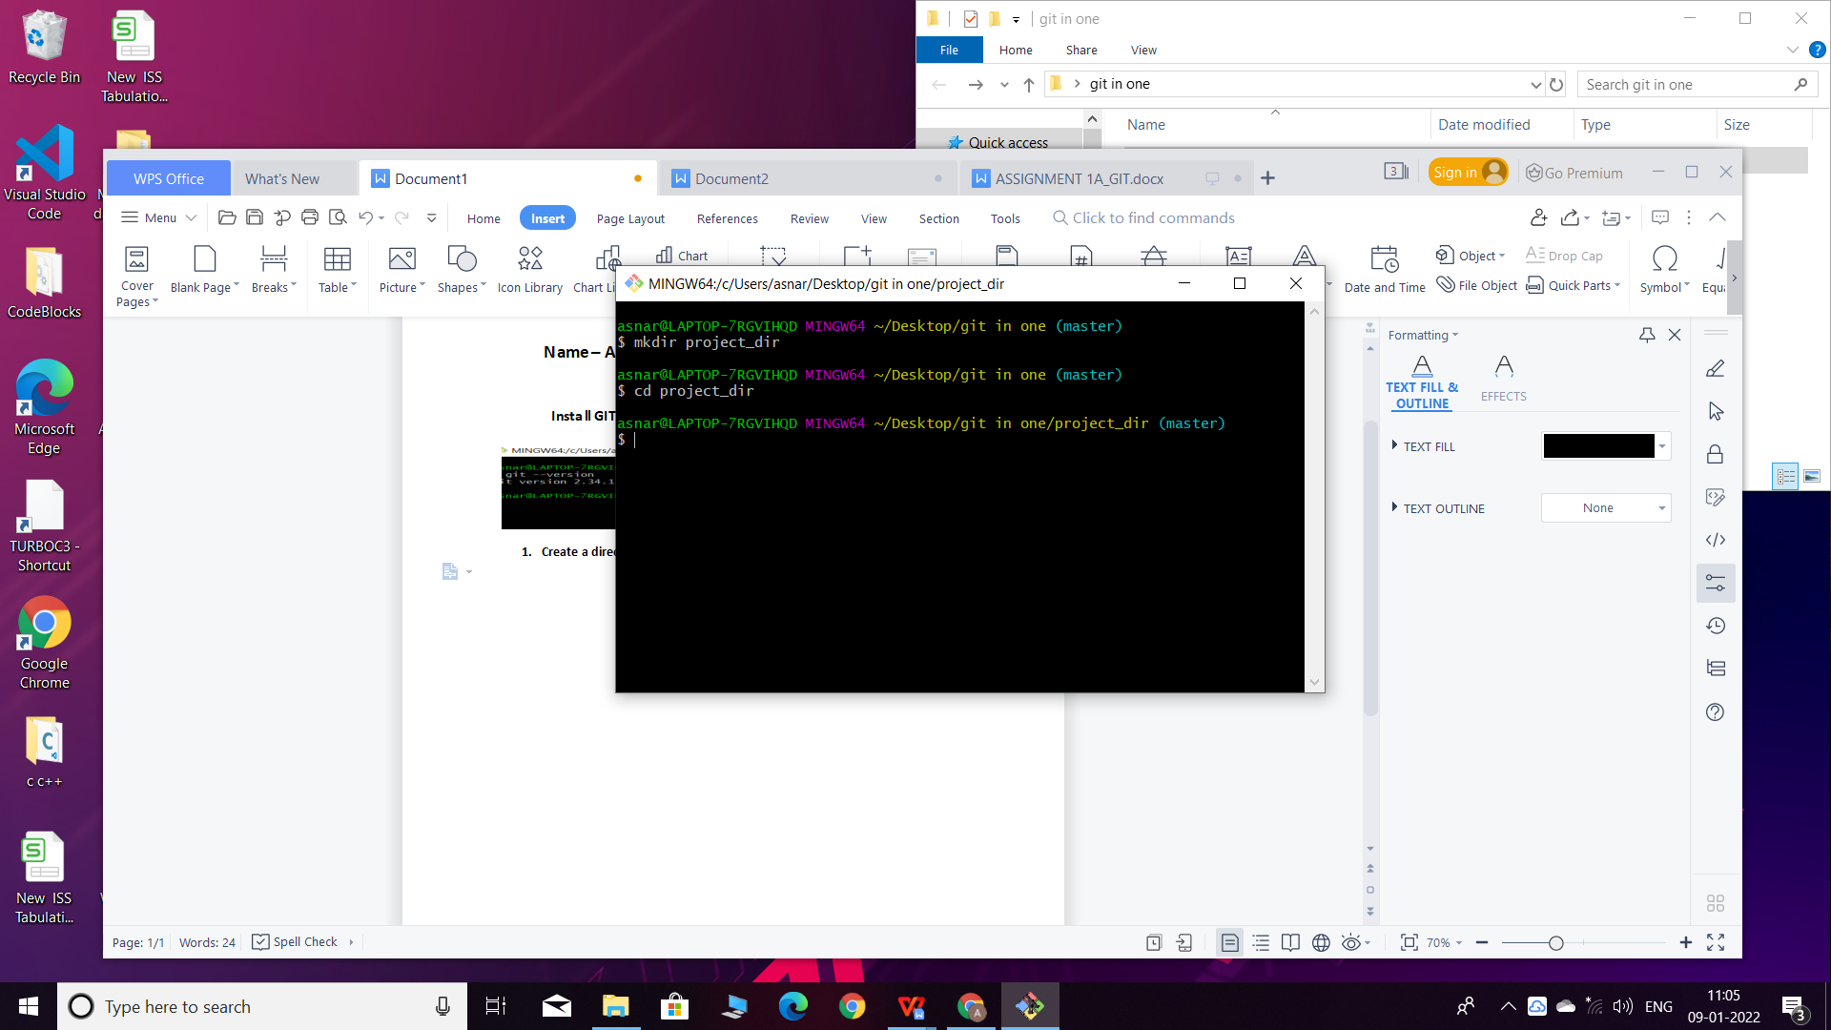

1. Initialize git version database. (git init).

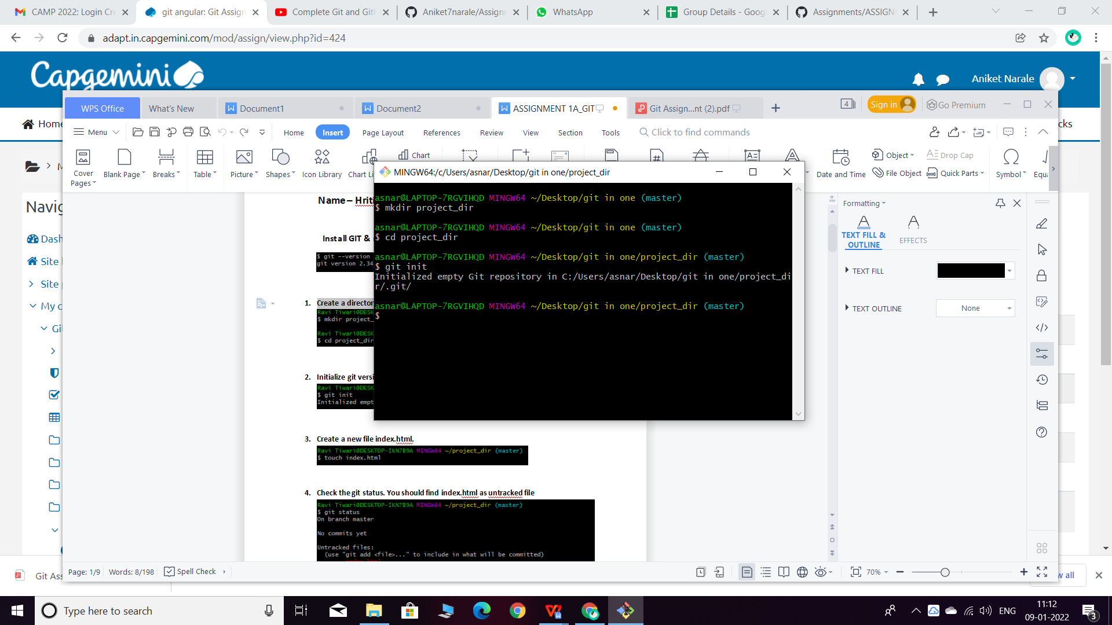

1. Create a new file index.html.

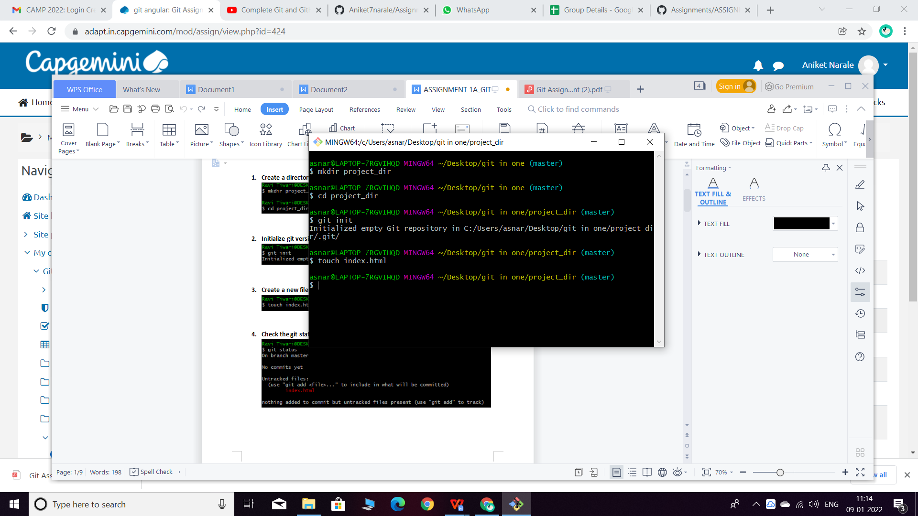

1. Check the git status. You should find index.html as untracked file.

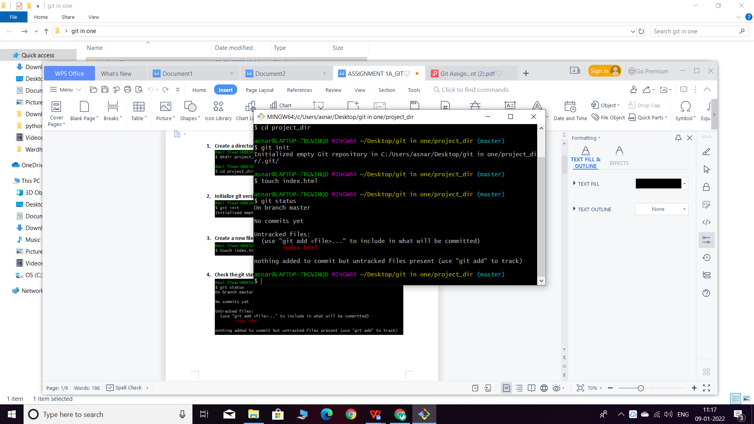

5. Stage the index.html file.

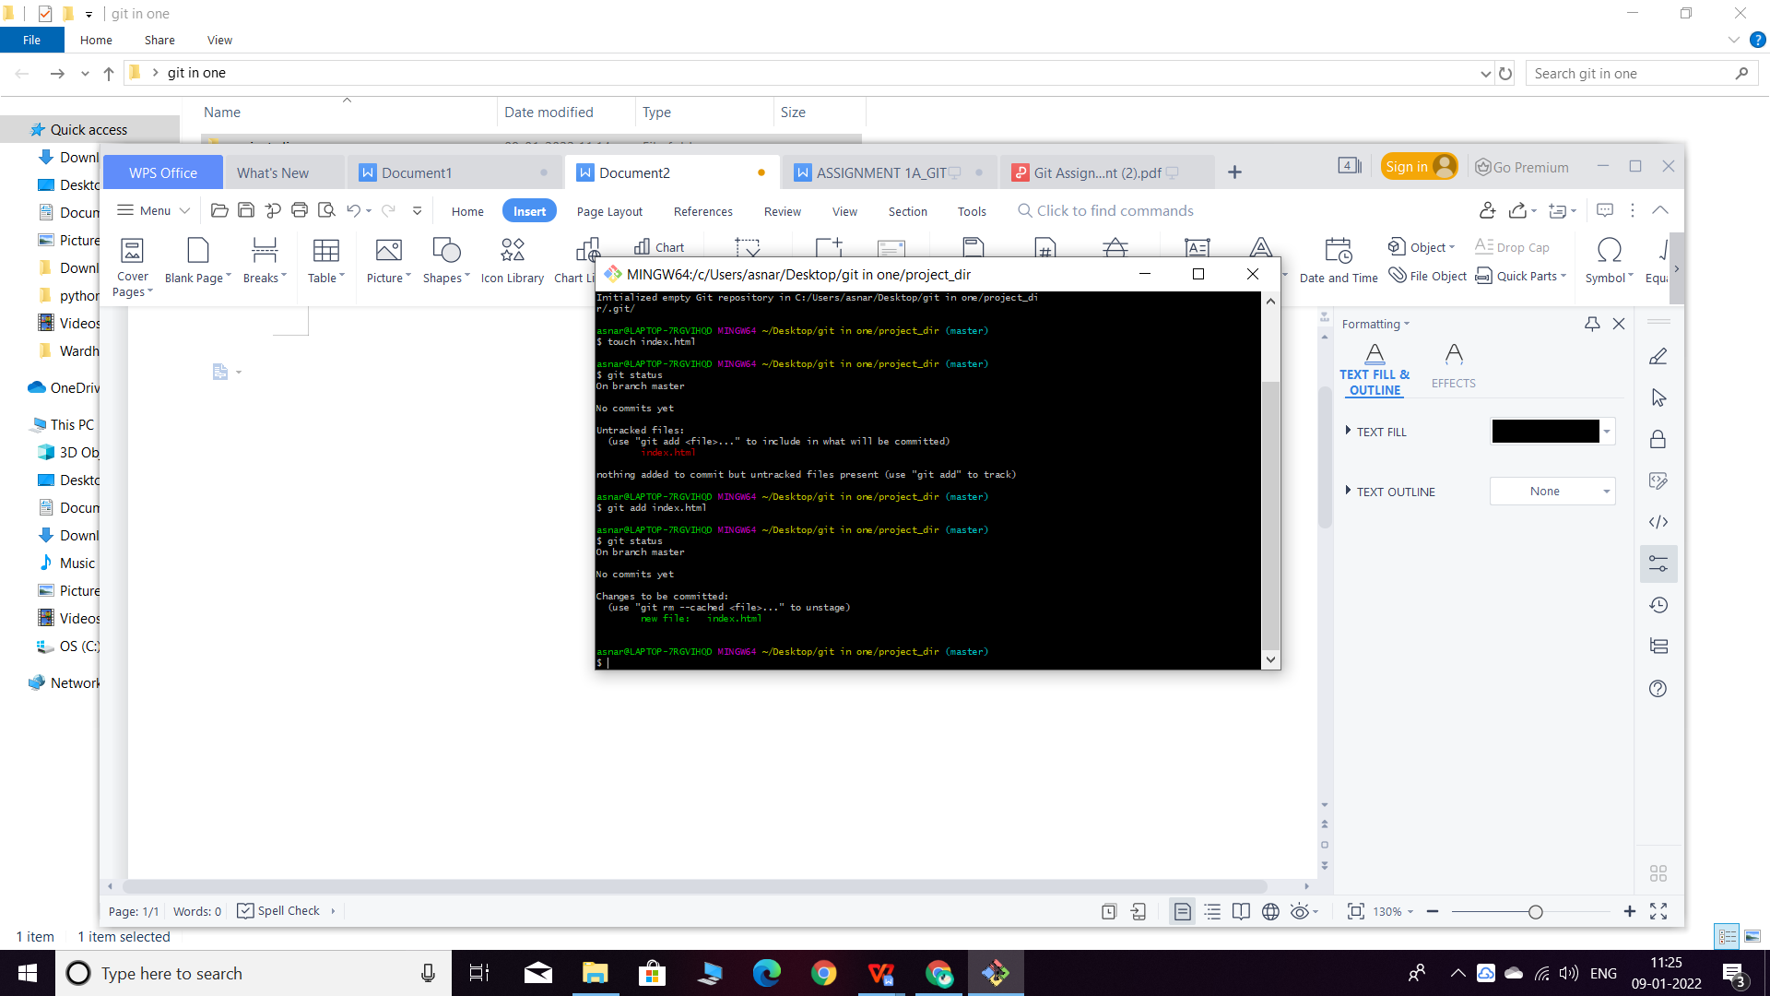6. Commit index.html.

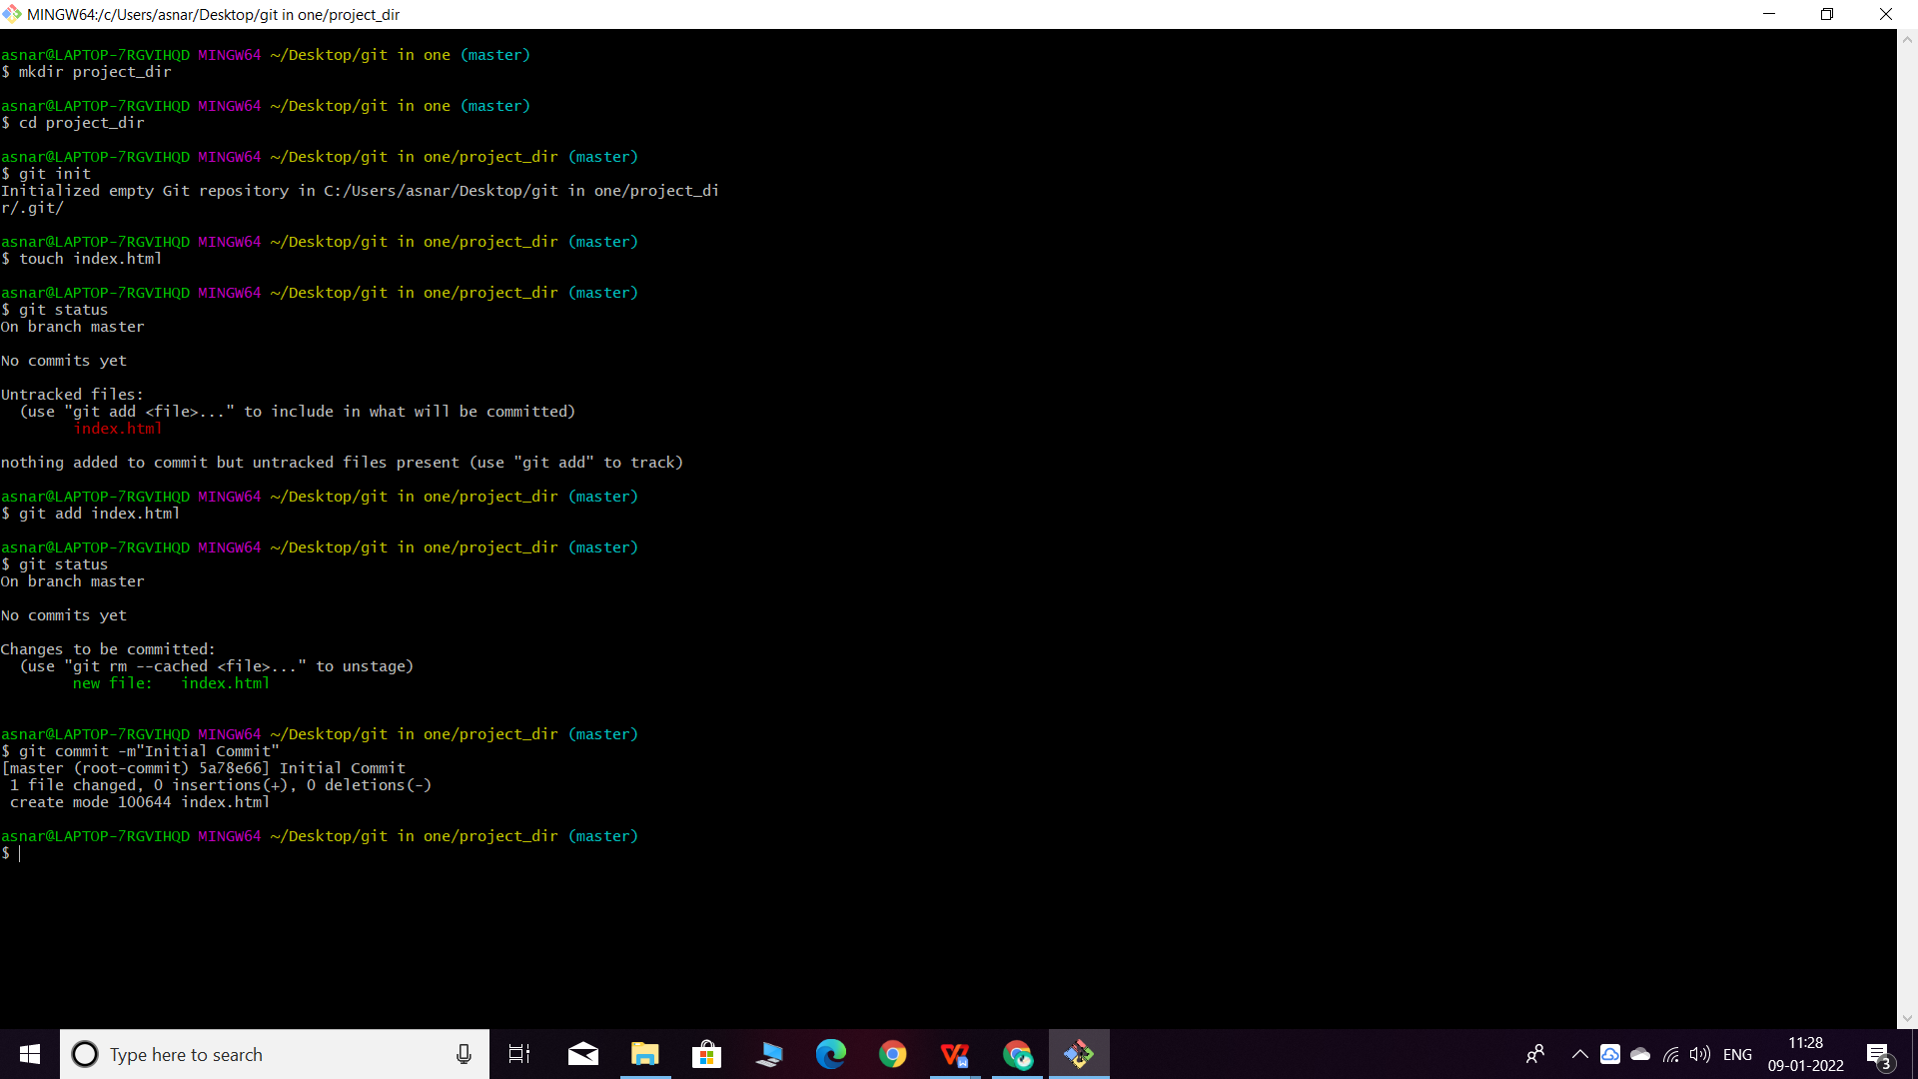

1. Make few changes in index.html & create a new file info.txt file.

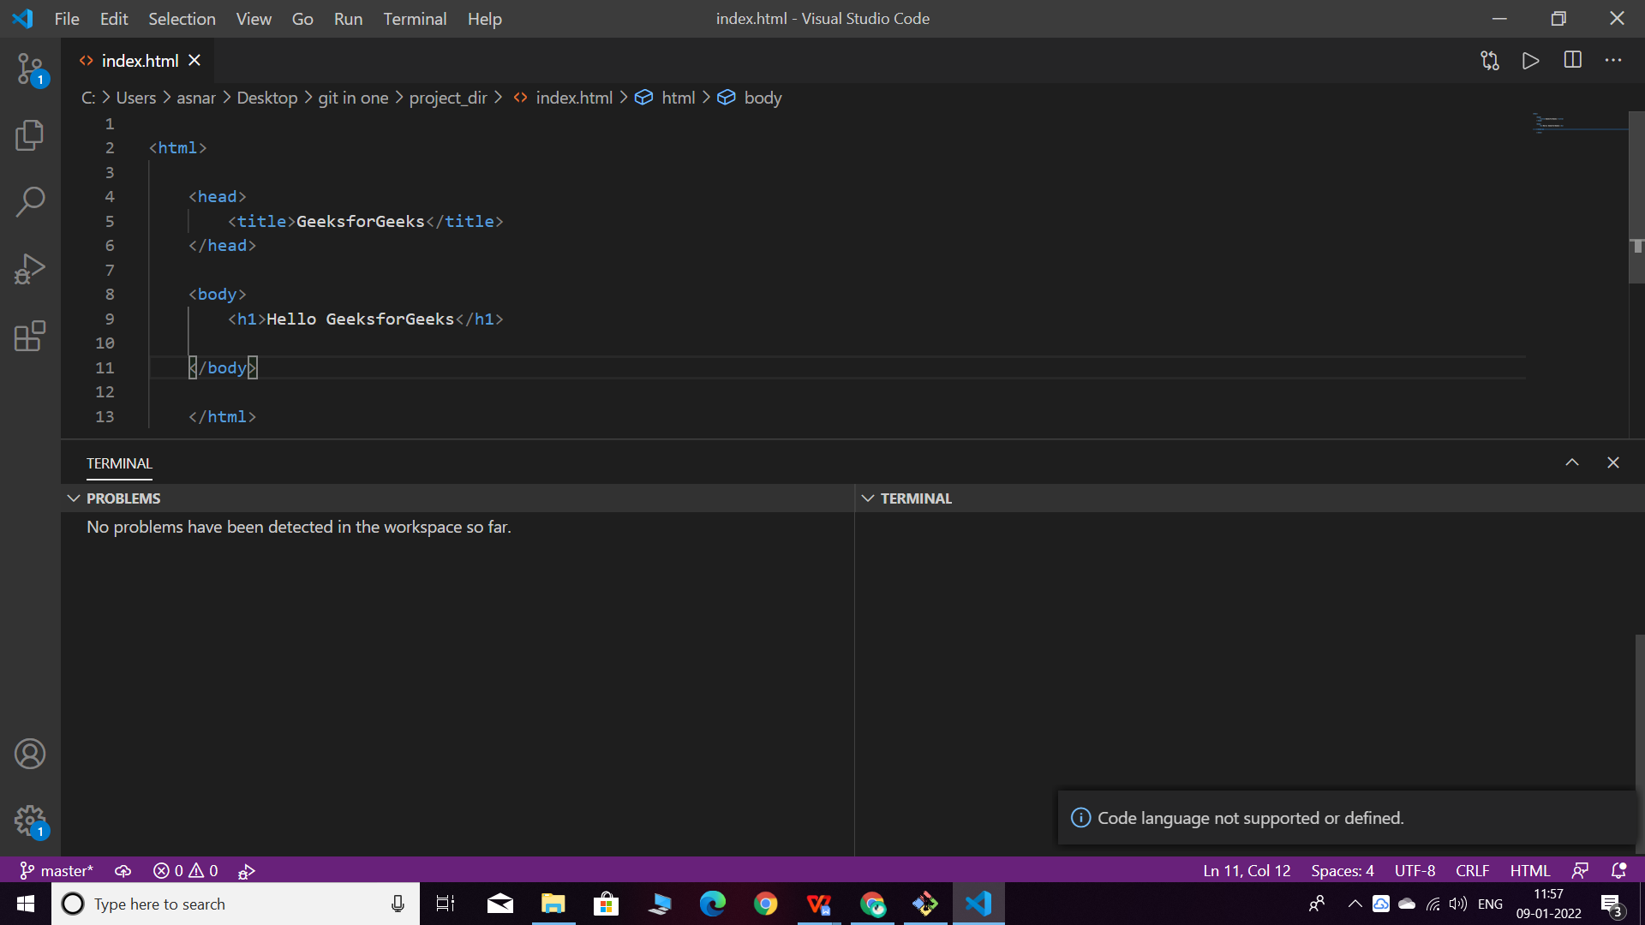

1. Check git status. You should find index.html & info.txt as untracked files.

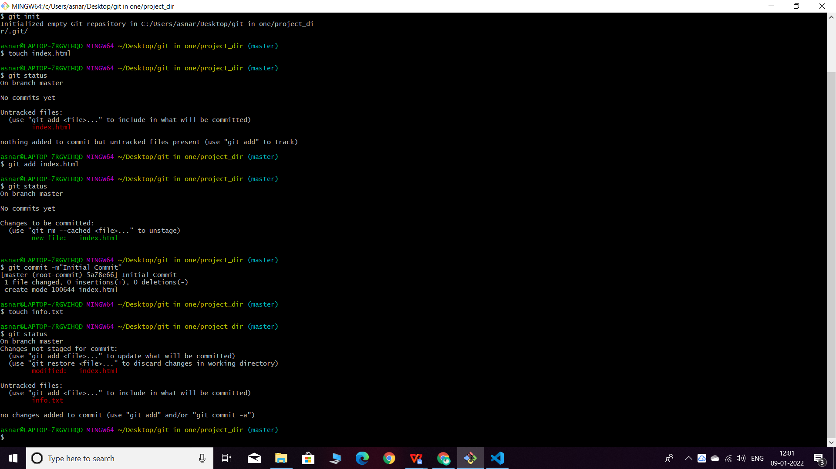

1. Configure GIT to ignore all txt files.

**Used *txt in the gitignore file to not include text using vscode**

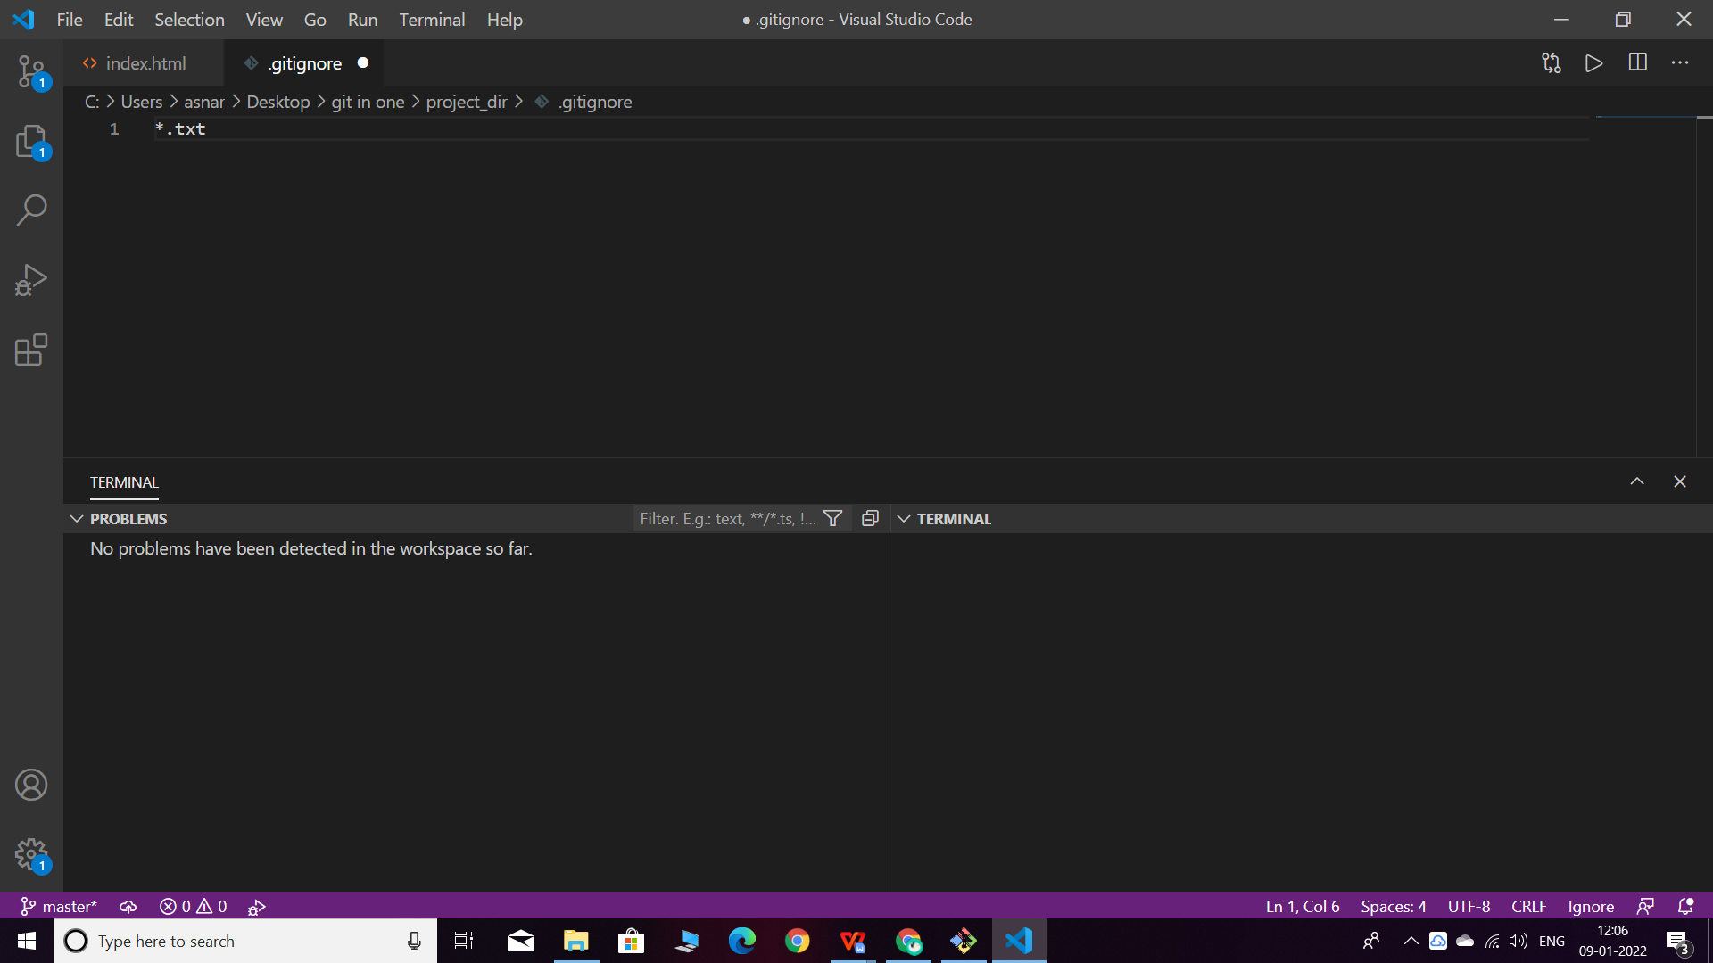

**Created new file**

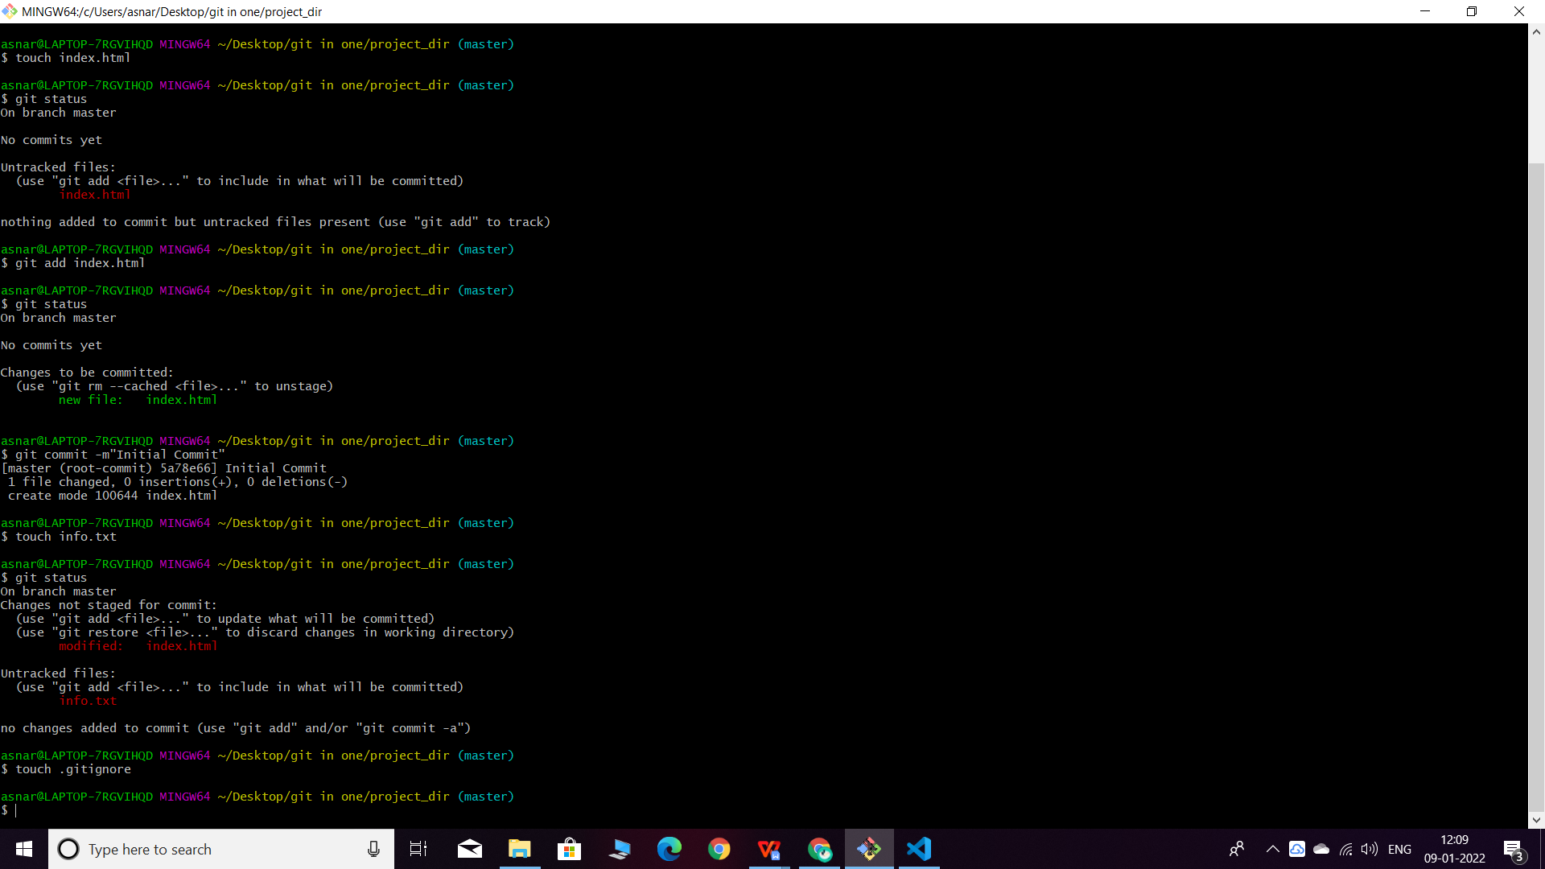**Added .gitignore into the staging area**

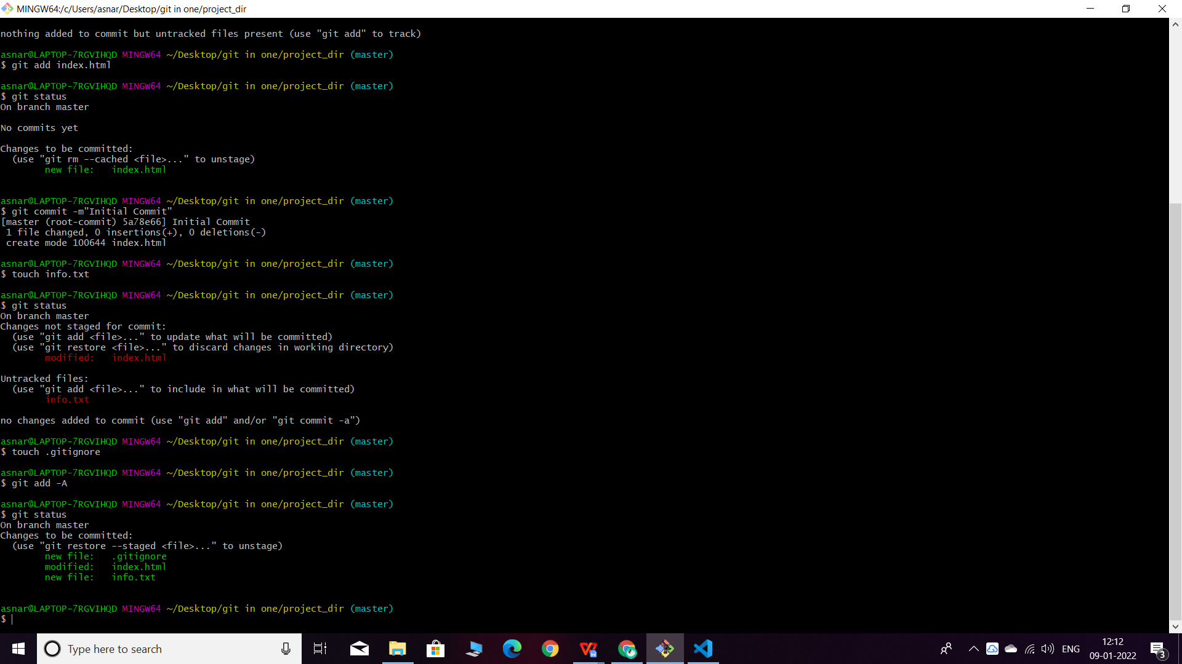

**Commited .gitignore**

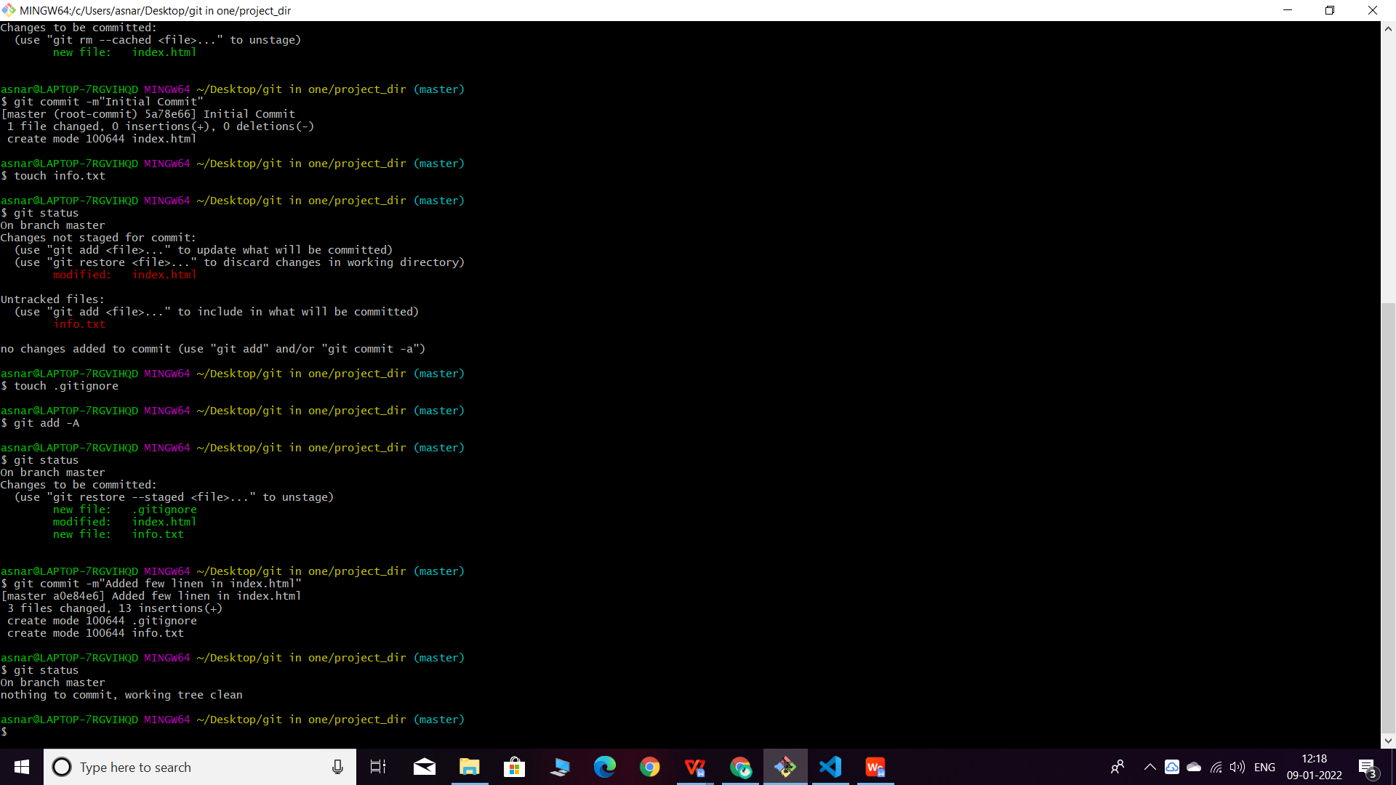10. Again check the git status. You should find only index.html as untracked file.

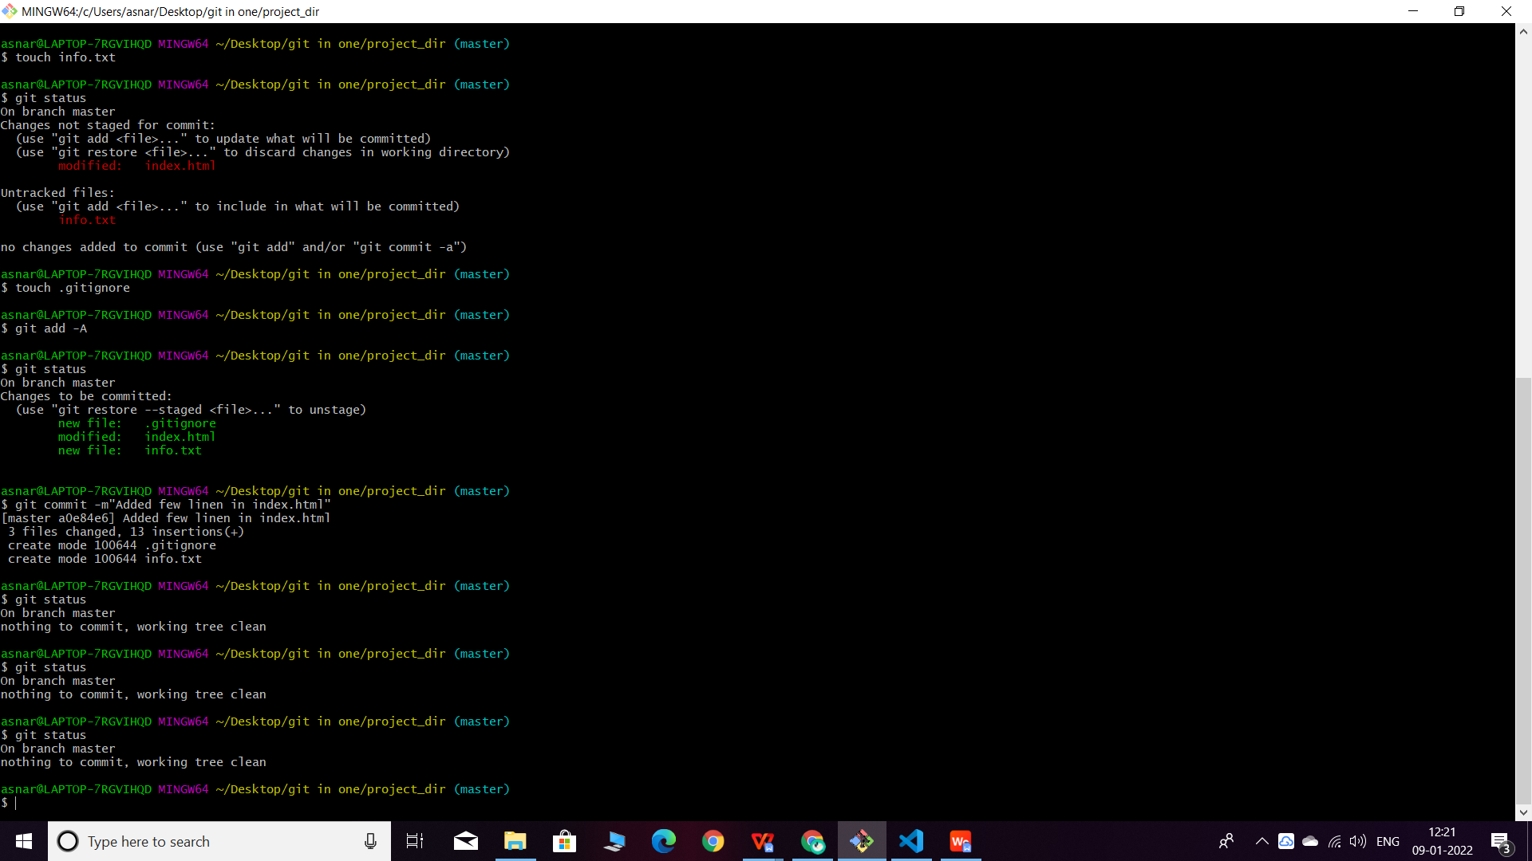11. State & commit index.html

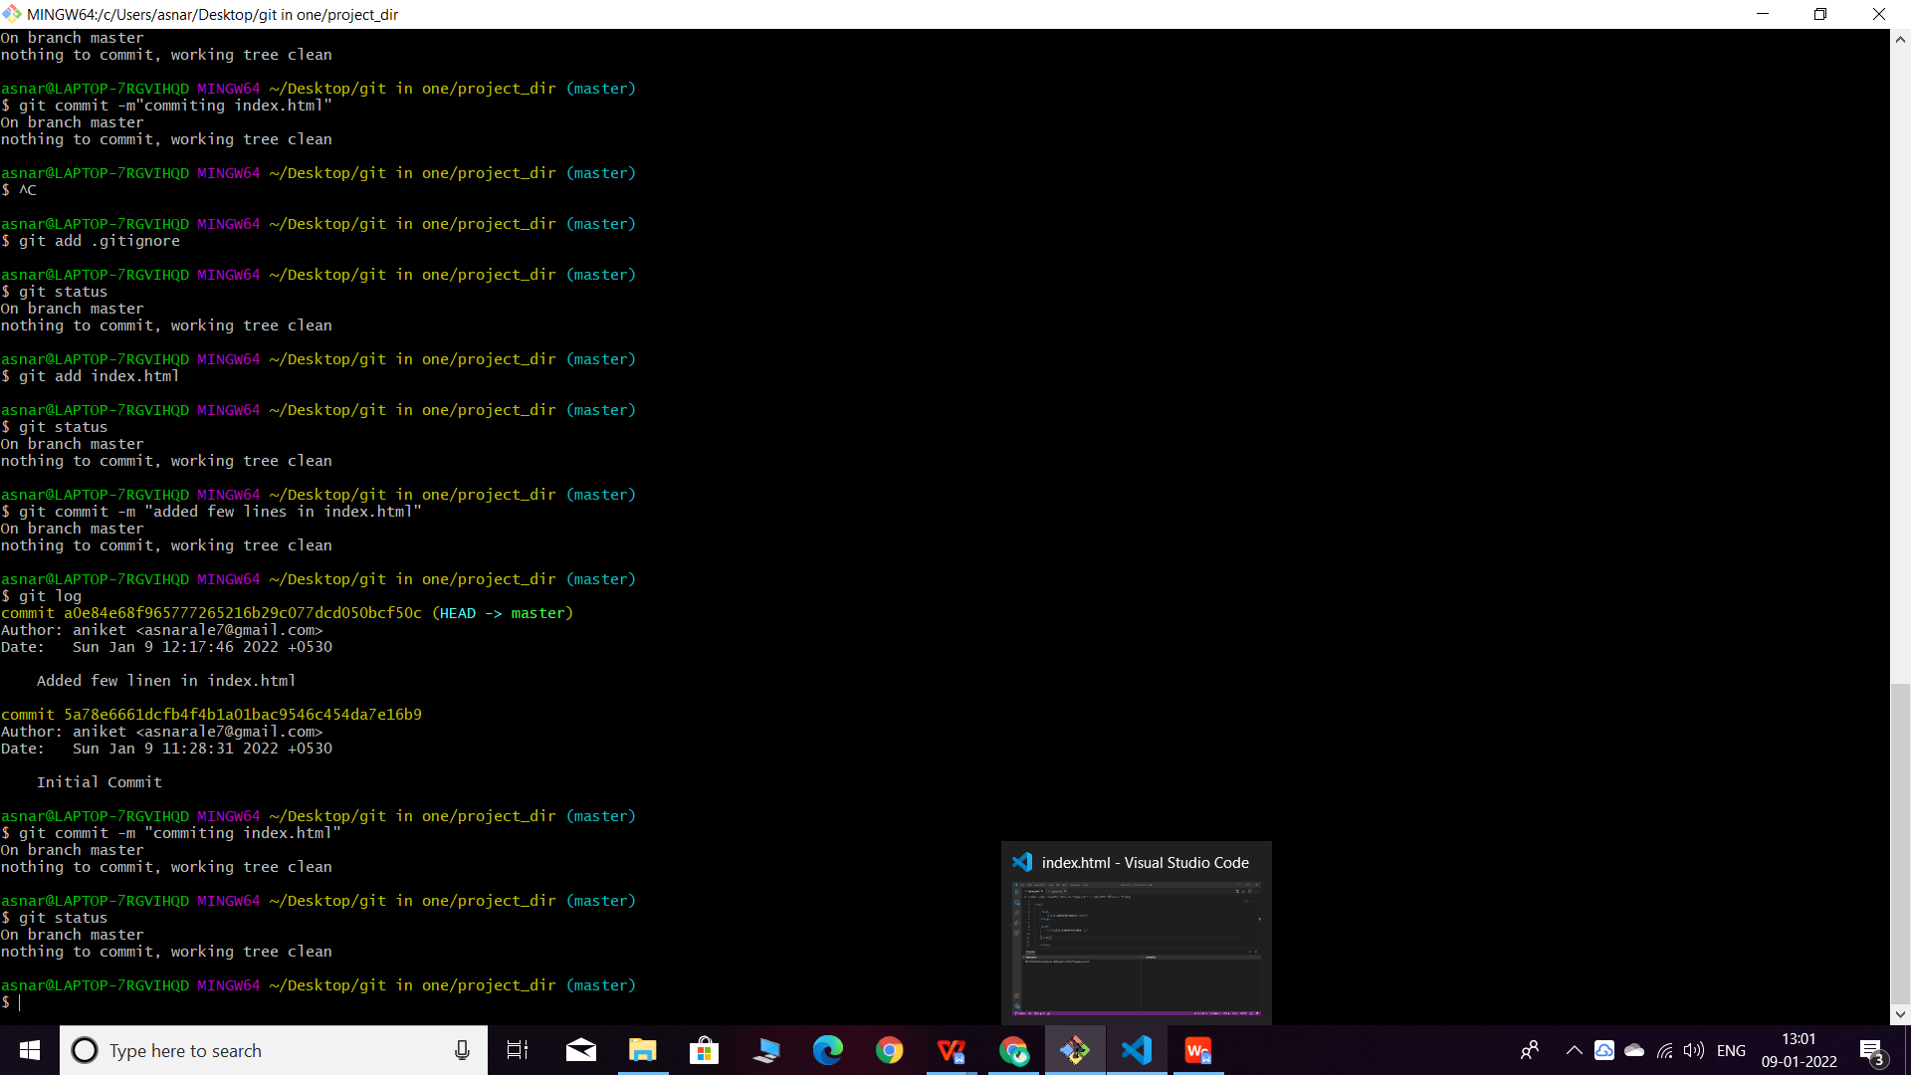

1. Log all your comments so far

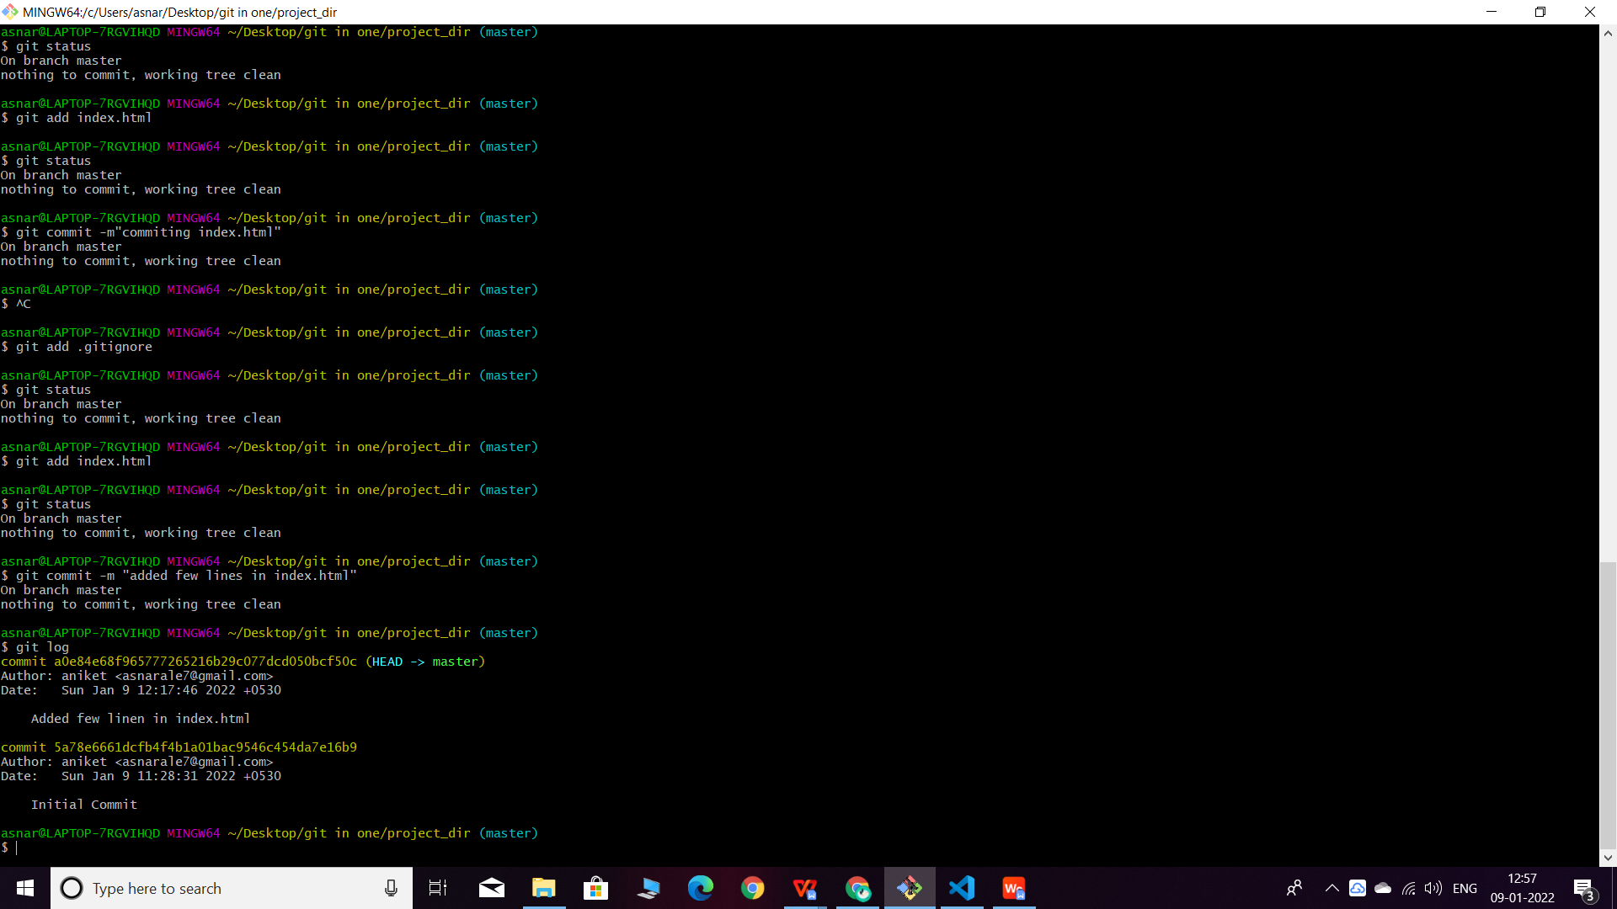

1. Make some changes in index.html.

Command used for checking difference. Git diff index.html.

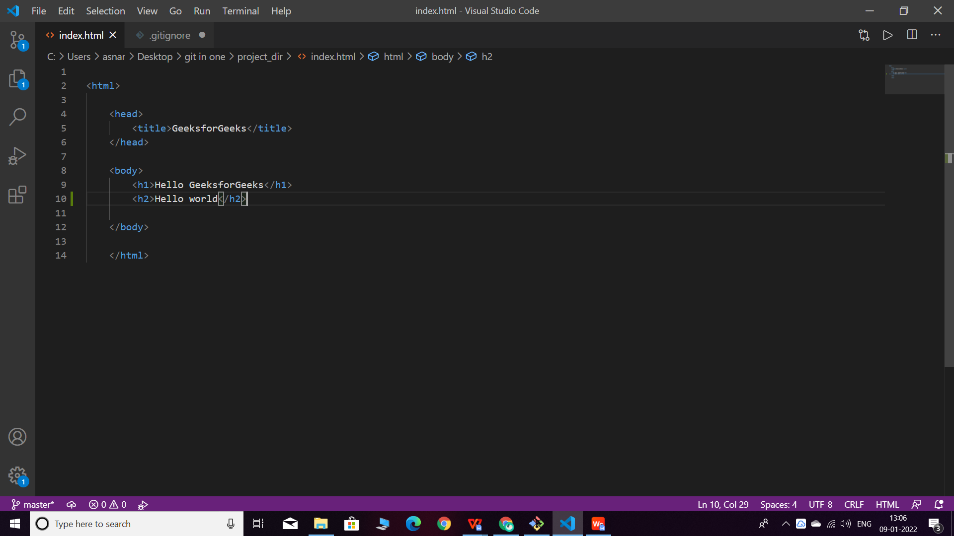

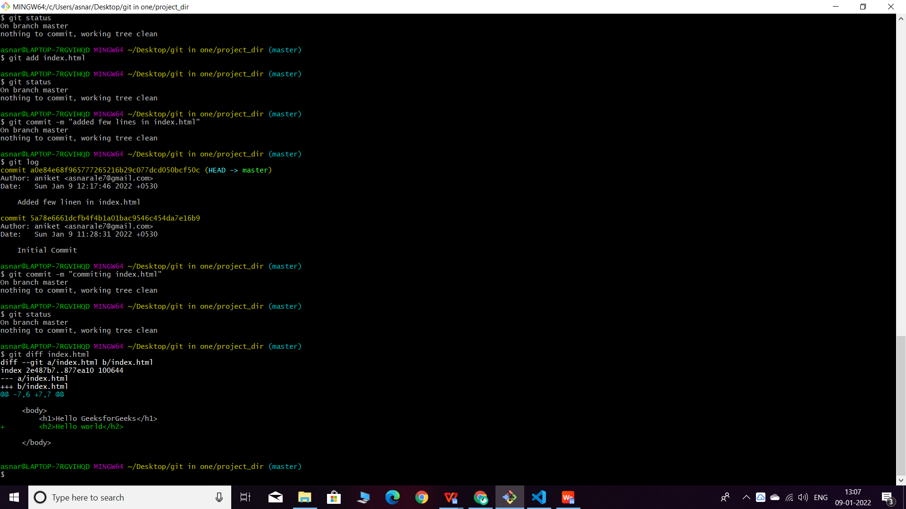

14. Revert the change made in the previous step using git command.

Command used for reverting back the changes made.

Git checkout index.html

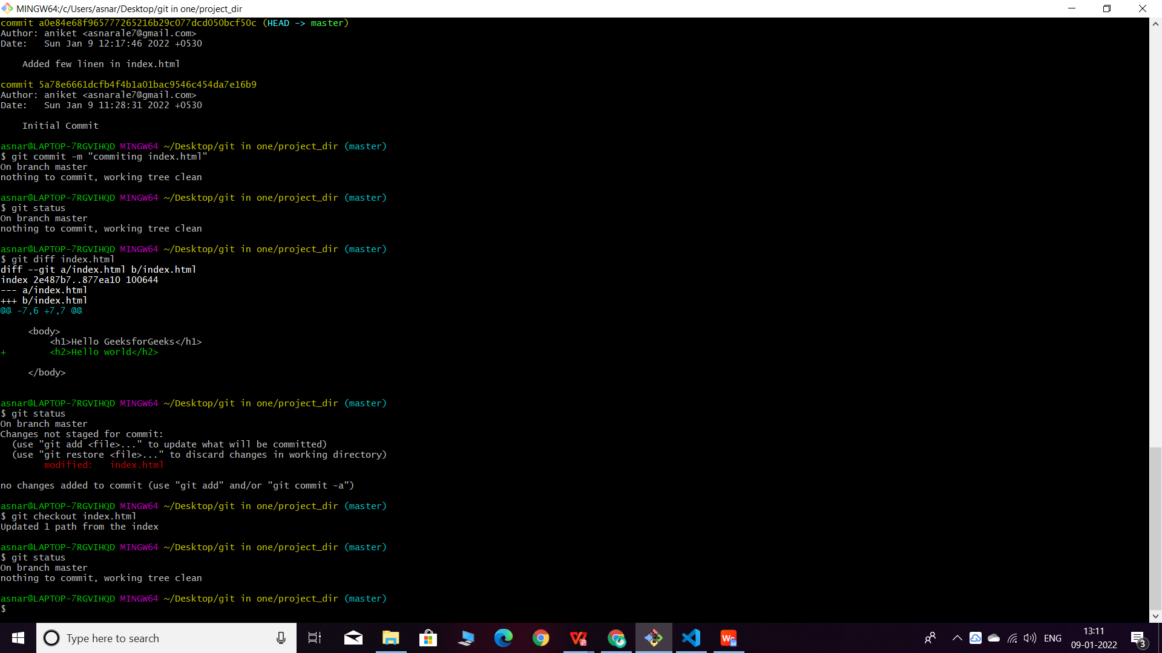

All changes made are revert back to the previous commit

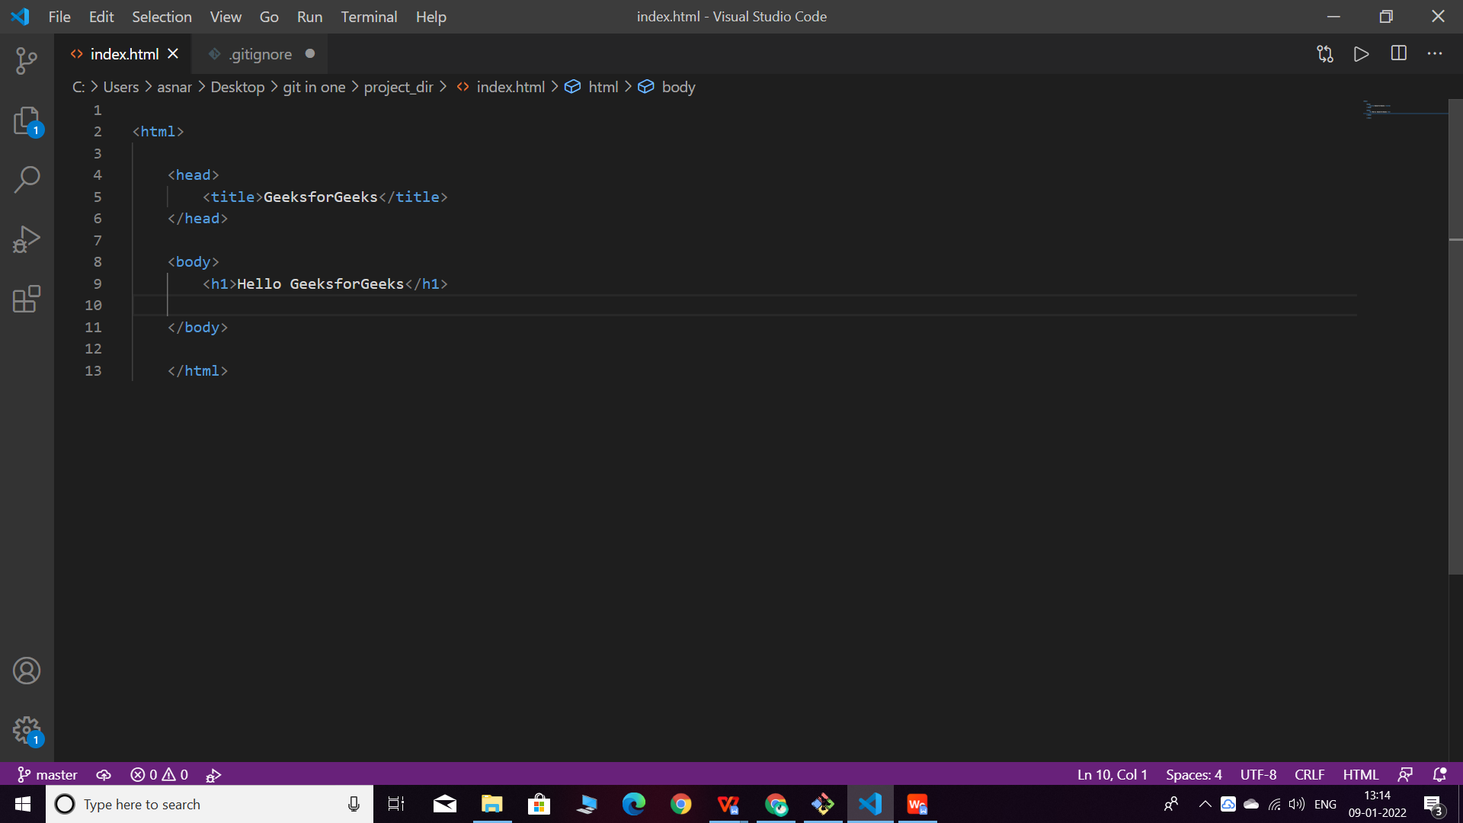

15.Again change index.html.

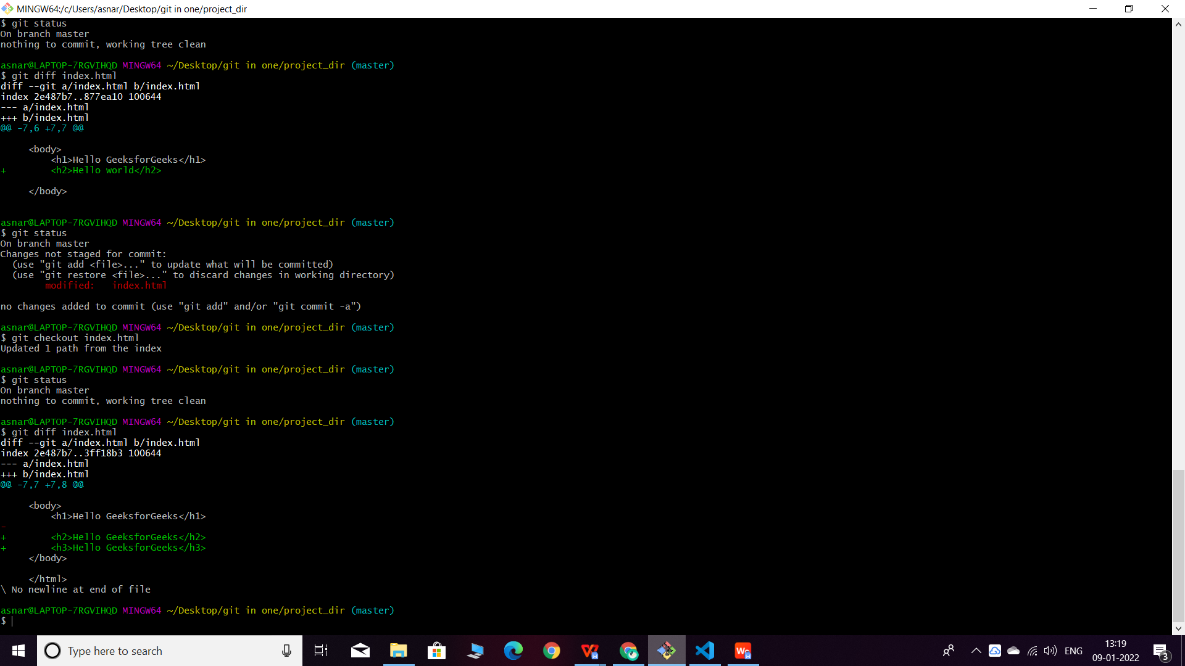

16. Stage index.html

Command used for staging

Git add index.html

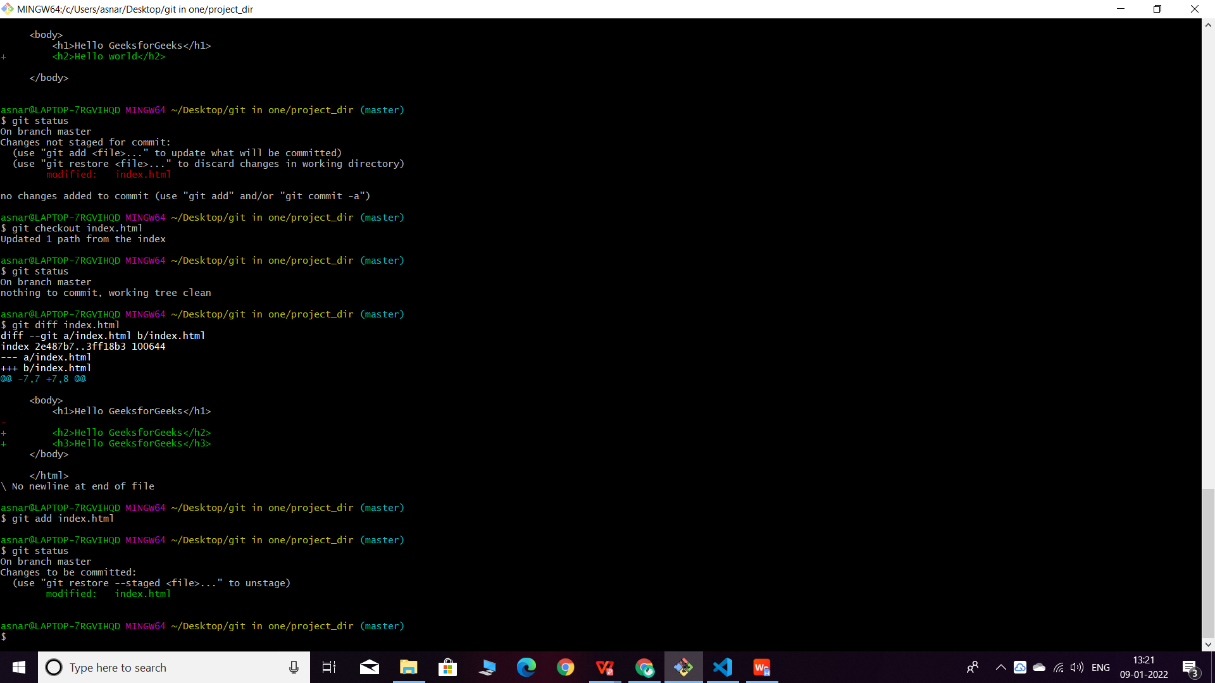

17. Revert back the last stage.

Command used for reverting back previous commit

Git checkout -f

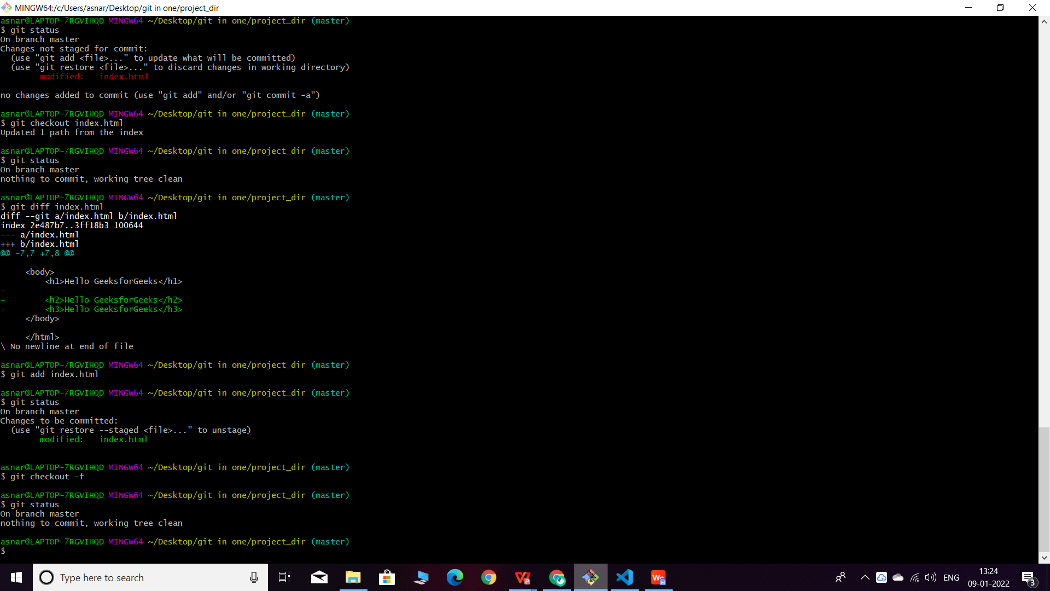

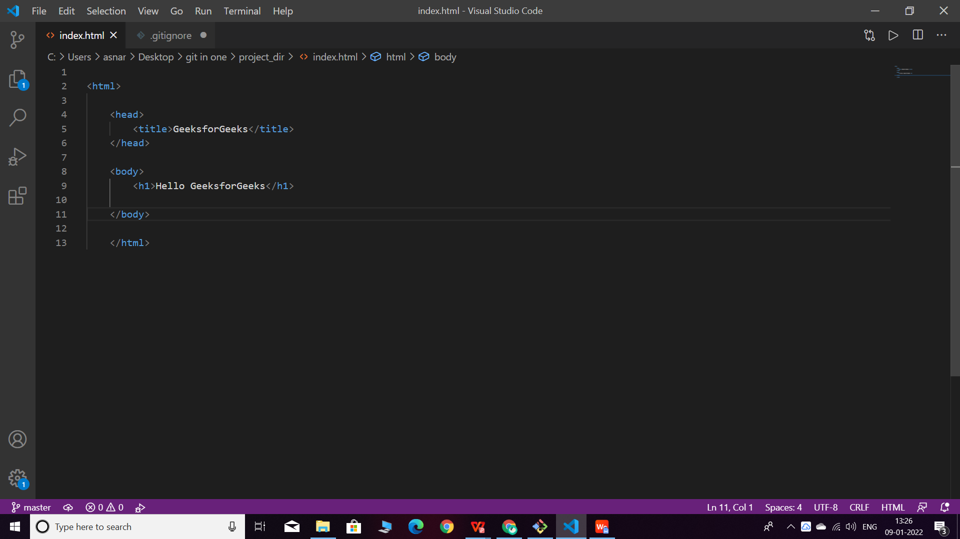

1. Rename ‘add’ command to ‘my-add’

Command used for renaming ‘add’ to ‘my-add’

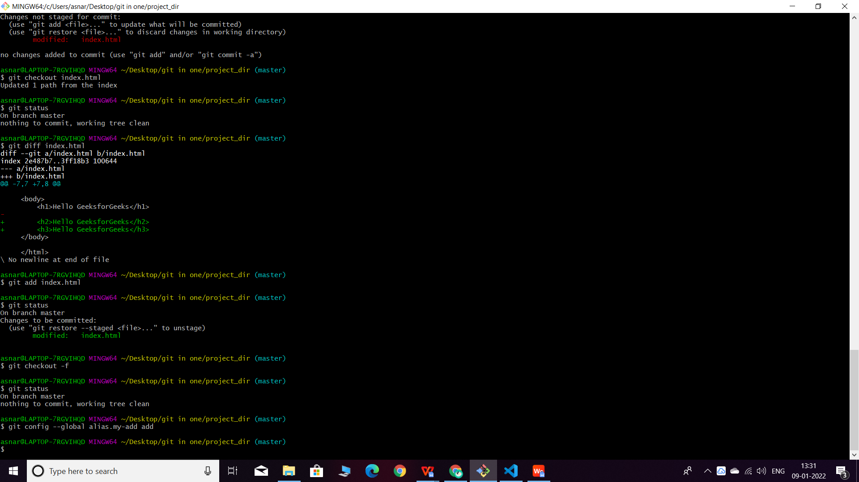

1. Using my_add command Stage index.html again & commit the changes.

Command used for staging index.html

Git my-add index.html

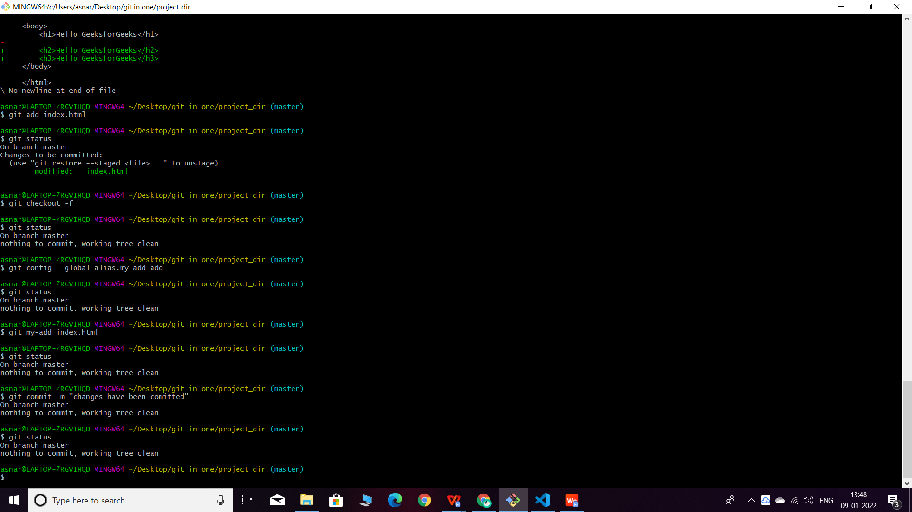

1. Revert the last commit.

COMMAND-Git revert HEAD

